FIGURE OUT YOUR SKILLS
What are skills?
Skills are abilities that are developed through life and work experiences. If you’re not sure what your skills are then your first step is to identify them. Figuring out your skills will help you decide what sort of job you might like, what areas you may need to improve through further study or training, and help you write your CV.
Fill in the table below writing about:
- What have I done? List any paid, unpaid and/or voluntary work you have had. If you’ve never had a job list all your interests and activities e.g. play sport, school project, drama group.
- What did this involve? With each thing you have listed above break it down in terms of what it involved – describe your main tasks and responsibilities. For subjects at school, think about the assignments and projects you did and what your involvement in these was.
- What skills did I use? Skills can be divided into hard skills and soft skills:
  - Hard skills are teachable abilities meaning you learn them in school or on a training course or on the job e.g. a specific computer program, a foreign language, how to drive.
  - Soft skills are personal skills, qualities or attitudes that you pick up and develop throughout your life. They are sometimes called transferable skills or employability skills because they are useful in many different types of jobs. You don’t have to have had a job to learn these, you can pick up soft skills from your daily life e.g. childcare skills if you are looking after a younger brother or sister, budgeting and planning if you are helping out with the shopping. You can also learn skills from the subjects you study e.g. drama develops your communication skills, maths develops your problem-solving skills, group projects develop your teamwork skills. So your school and home life can develop a lot of different skills without perhaps you even realising it.

FIGURE OUT YOUR SKILLS IN THREE STEPS
 | 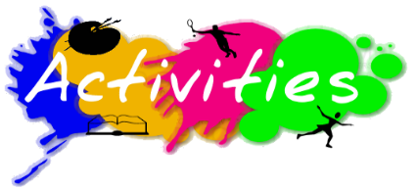  1.What have I done?  e.g. worked in a café for one year | 2.What did this involve?  e.g.took orders, served food, cleaned tables | 3.What skills did I use?  e.g. customer service, communication skills
1
2
3
4

